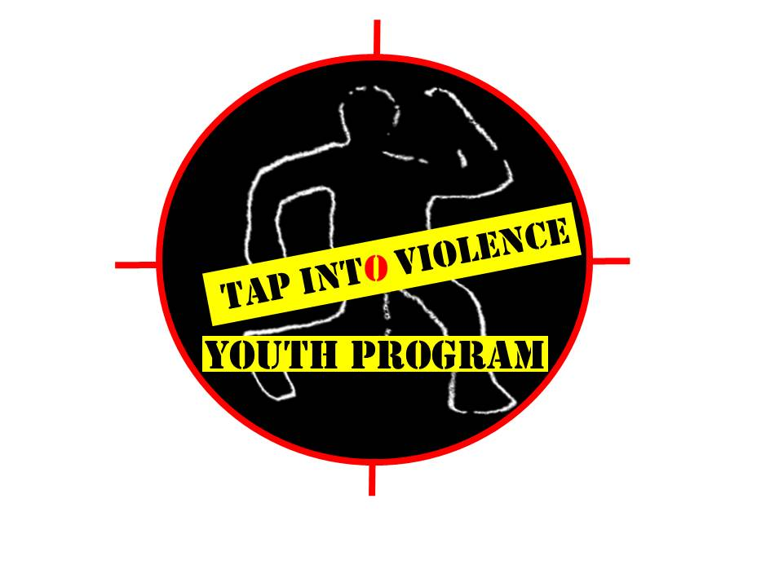

SAVE OUR YOUTH SKATEBOARD COMPETITION
Registration Form
Participant Name: ______________________________________________ DOB: _____________

Address: ____________________________________________ City: ______________ State: _____

Phone Number: ____________________________ Cell: ___________________________

Email: ____________________________________________________________________________

Emergency Contact: _____________________________ Emergency Contact Number: ______________

If under 18 years of age and/or currently in school:
Name of School: ___________________________________________ Grade: ______________

I hereby give permission for my son/daughter to participate in the SAVE OUR YOUTH SKATEBOARD COMPETITION. I understand that he/she will participate in a community skateboard competition before an audience and the event will be held at the Heaven Skatepark, US-6, Downtown Hartford, CT. The SAVE OUR YOUTH SKATEBOARD COMPETITION is scheduled to for Sunday, September 13, 2015 from 12:00pm-5:00pm.
I hereby waive and release Tap Into Violence Youth Program, Platinum Souls Media and The City of Hartford and its program directors, volunteers, officers, agents and staff from any and all liability for injuries or illness incurred to, from or during the SAVE OUR YOUTH SKATEBOARD COMPETITION. I also permit Tap Into Violence Youth Program and Platinum Souls Media to retain the rights to use photographs and video of participants for publicity and/or website purposes.
Participant: ______________________________________ Date: ______________
Under 18 years old:
Parent/Guardian: ___________________________________ Date: ______________
Updated 8/15
Fee Paid:

